****

**BHARATI VIDYAPEETH COLLEGE OF ENGINEERING**

**DEPARTMENT OF ELECTRONICS AND TELECOMMUNICATION**

**CERTIFICATE**

This is to certify that the project stage-2 entitled

**“INDUSTRIAL TEMPERATURE CONTROLLER”**

is submitted by

Name of student:

Pravin Lad

Jayesh Laxkar

Pooja Pardhi

have successfully carried out the project from July 2015to April 2016 as partial fulfillment of their Bachelor ‘s degree in **Department of Electronics &Telecommunication Engineering** affiliated to UNIVERSITY OF MUMBAI for the academic year 2015-2016.

**Internal guide** **HOD**  **Principal**

**Internal Examiner External Examine**

**BHARATI VIDYAPEETH**

**COLLEGE OF ENGINEERING**

**SECTOR-7 C.B.D BELAPUR**

**NAVI MUMBAI-400614**

**PROJECT REPORT ON**

**“INDUSTRIAL TEMPRETURE CONTROLLER”**

Submitted By

NAME-Pravin Lad

Jayesh Laxkar

Pooja Pardhi

**Under the Guidance**

**Prof: P.A. Kharade.**

**Department of Electronics & Telecommunication Engineering**

**2015-2016**

**INDEX**

|  |  |  |
| --- | --- | --- |
| **Chapter** | **Contents** | **Page No.** |
| 1 | Acknowledgement | 1 |
| 2 | Introduction | 2 |
| 3 | Objective | 3 |
| 4 | Block diagram | 4 |
| 5 | Working | 5 |
| 6 | Advantages and disadvantages | 10 |
| 7 | Applications and future scope | 11 |
| 8 | Conclusion | 12 |
| 9 | References | 13 |
| 10 | Datasheets |  |

**Acknowledgement**

We take this opportunity to present a project on **“INDUSTRIAL TEMPERATURE CONTROLLER”**. We made our sincere attempt to present this matter in precise and compact form. We would take an opportunity to thank the stalwart of this institution, our Principal Dr. M.Z.Shaikh for providing us all the required resources for our project. We would like to thank our Head of Department Prof. P.A.Kharade for constant motivation. We would also thank the projectconvener Prof. S.D.Jadhav for his moral support.

We would like to extend our heartfelt thanks to our guide Prof. P.A.Kharade who has been a constant guiding and supporting force behind us for the entire academic year and with whom we got to learn many new things. Lastly we would like to thank each and everyone who directly or indirectly has been a part of this project.

**Chapter1. Introduction**

Temperature is one of the main parameter to control in most of the manufacturing industries like chemical, food processing, pharmaceutical etc. In these kinds of industries some product need the required temperature to be maintained at highest priority the product will fail. So the temperature controller is most widely used in almost all the industries.

The goal of this project is to design an ambient temperature measurement and control circuit. The motivation for the project is the fact that temperature measurement has become an integral part of any control system operating in a temperature sensitive environment and the various learning outcomes associated during the implementation of the project.

It is basically a close loop control system. There are two types: ON-OFF type or continuous type system.

ON-OFF type- Temperature is sensed, displayed and it is compared with set value. If it is greater, then it switches off the heating element and if it is less, then switches on the heating element.

Continuous type- Temperature is sensed, displayed and it is compared with set value. If it is greater/less, then control the heat produced by heating element by changing its supply current.

In this project ON-OFF type controller has been implemented. Here the set value for temperature can be externally set by the user. The actual temperature is sensed by the temperature sensor. It is displayed on LCD with the set value. If it exceeds the set value the heater is turned off. After then when temperature falls below the specified limit again heater is turned on.

**Chapter 2. Objective**

The basic idea of the project is to design a temperature controller which will have competitive design when compared to the temperature controllers now present in the market. The design we are working on have some added features so that the design can be preferred over the others presently in the market. The damage or loss due to failure of the heater coil or the thermocouple is major problem in the industry. In order to solve that problem we have introduced pre failure alarm in the design. Because of this we will get alarm before the failure of the sensor or the heater coil. And the losses due to it can be reduced.

We are trying to increase the number of interfacings to the system so that the accessibility of the user to the system can be improved. We are trying to implement the concept of human machine interface (HMI) in the design. And we are still working on it. Some of the other interfaces added are computer interfacings using RS 232 socket, LCD display, RF module, etc.

In normal relays mechanical movement is involved hence chances of error due to shock wave or lag due to delay in switching are some of the common problems which may occur to remove that and have more perfect output we have used solid state relays for switching in the circuit which will lead to more accurate and lag free switching without much distortion. The triac is used as the switching element at the heater coil. And to trigger it and to commute the circuit external circuit is used as we are going to see in further project report.

As extra features we have added number of interfacings in order to improve accessibility of the system. Pre failure alarm is also a feature that will add to value of the design.

**Chapter 3: Block diagram**

Zigbee Module

LCD

USB interfacing

intin

**HMI**

**LCD**

**INTERFACING**

**PRE & POST FAILURE ALERT SYSTEM**

**HEATER BAND/**

**HEATING COIL**

**SOLID STATE RELAY TRIGGERING CKT**

**CONTROL UNIT ATMEGA 32**

**PRE & POST FAILURE ALERT SYSTEM**

**TEMPERATURE SENSOR THERMOCOUPLE**

**Output**

**Chapter 4: Working**

* 1. **Thermocouple:-**

**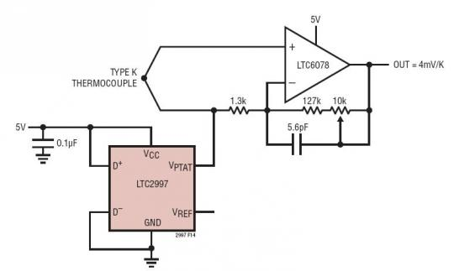**

Thermocouples convert temperature to voltage. They rely on Seebeck effect which states that a junctionof different metals will generate a voltage that is proportional to the temperature of the metals.

Thermocouples are low cost temperature sensors, they are readily available from multiple sources andthey can measure a wide range of temperatures that cannot be measured with semiconductor typetemperature sensor. For example, they can be used to measure the temperature of the inside of aceramics kiln which can reach 1200 Celsius.The temperature range of a thermocouple depends on the type of metals that make up the thermocouple.

The types of thermocouples based on its ranges and material used is given in the table:

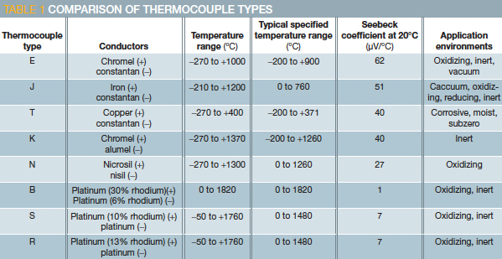

Thermocouples give out voltages in the range of micro volts so the output of a thermocouple must beamplified before it can be converted into a digital value.

**Principle of operation:**

In 1821, the [German](https://en.wikipedia.org/wiki/Germany) physicist [Thomas Johann Seebeck](https://en.wikipedia.org/wiki/Thomas_Johann_Seebeck) discovered that when different metals are joined at the ends and there is a temperature difference between the joints a magnetic field is observed. At the time Seebeck referred to this as thermo-magnetism, the magnetic field he observed was later shown to be due to thermo-electric current. In practical use the voltage generated at a single junction of two different types of wire is what is of interest as this can be used to measure temperature at very high and low temperatures. The magnitude of the voltage depends on the types of wire used. Generally, the voltage is in the microvolt range and care must be taken to obtain a usable measurement. Although current flows very little, power can be generated by a single thermocouple junction. Power generation using multiple thermocouples, as in a [thermopile](https://en.wikipedia.org/wiki/Thermopile), is common.

[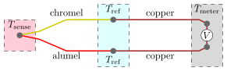](https://en.wikipedia.org/wiki/File:Thermocouple_circuit_Ktype_including_voltmeter_temperature.svg)

[K-type](https://en.wikipedia.org/wiki/Thermocouple#Type_K) thermocouple ([chromel](https://en.wikipedia.org/wiki/Chromel)–[alumel](https://en.wikipedia.org/wiki/Alumel)) in the standard thermocouple measurement configuration. The measured voltage \scriptstyle Vcan be used to calculate temperature \scriptstyle T_\mathrm{sense}, provided that temperature \scriptstyle T_\mathrm{ref}is known.

The standard configuration for thermocouple usage is shown in the figure. Briefly, the desired temperature Tsense is obtained using three inputs—the characteristic function E(T) of the thermocouple, the measured voltage V, and the reference junctions' temperature Tref. The solution to the equation E(Tsense) = V + E(Tref) yields Tsense. These details are often hidden from the user since the reference junction block (with Tref thermometer), voltmeter, and equation solver are combined into a single product.

**Physical Principles:**

Seeback Effect:

It states that when two different or unlike metals are joint together at two junctions,an electromotive force is generate at two junction but the amount of emf generated is different for different combination of metal.

Peltier Effect:

as per the peltier effect,when two dissimilar metals are joint together to form two junction,emf is generated within the circuit due to the different temperature of two junctions of the circuit.

Thomson Effect:

as per Thomson effect when two unlike metals are join forming to junctions,the potential existswithin the circuit.due to the themperature gradients along entire length of the conductors within the circuit.in most of the cases theemf suggested by the Thomson effect is very small and it can be neglected by making proper selection of metal.the peltier effect play prominent role in the working principle of thermocouple.

**4.2Atmega 16:-**

**ATmega16** is an 8-bit high performance microcontroller of Atmel’s Mega [AVR](http://www.engineersgarage.com/articles/avr-microcontroller) family with low power consumption. Atmega16 is based on enhanced RISC (Reduced Instruction Set Computing, Know more about [RISC and CISC Architecture](http://www.engineersgarage.com/articles/risc-and-cisc-architecture)) architecture with 131 powerful instructions. Most of the instructions execute in one machine cycle. Atmega16 can work on a maximum frequency of 16MHz.

ATmega16 has 16 KB programmable flash memory, static RAM of 1 KB and EEPROM of 512 Bytes. The endurance cycle of flash memory and EEPROM is 10,000 and 100,000, respectively.

ATmega16 is a 40 pin microcontroller. There are 32 I/O (input/output) lines which are divided into four 8-bit ports designated as PORTA, PORTB, PORTC and PORTD.

ATmega16 has various in-built peripherals like [USART](http://www.engineersgarage.com/embedded/avr-microcontroller-projects/serial-communication-atmega16-usart), [ADC](http://www.engineersgarage.com/embedded/avr-microcontroller-projects/adc-circuit), [Analog Comparator](http://www.engineersgarage.com/embedded/avr-microcontroller-projects/analog-comparator-circuit), [SPI](http://www.engineersgarage.com/embedded/avr-microcontroller-projects/spi-serial-peripheral-interface-tutorial-circuit), [JTAG](http://www.engineersgarage.com/embedded/avr-microcontroller-projects/disable-jtag-port) etc. Each I/O pin has an alternative task related to in-built peripherals. The following table shows the pin description of ATmega16.

2. The Bootloader area, the NRWW section starts at word 0x3800 in ATmega32 while in ATmega16 it starts at 0x1C00.

3.  ATmega32 has a different interrupt table, the table given below shows the difference. More details can be obtained from the respective datasheets.

4.  In MCUCR register, the SM2 and SE bits are swapped, i.e., the SM2 bit is bit7 and SE bit is bit6 in MCUCR register in ATmega32.

### **Pin Description:**

|  |  |  |  |
| --- | --- | --- | --- |
| **Pin No.** | **Pin name** | **Description** | **Alternate Function** |
| 1 | (XCK/T0) PB0 | I/O PORTB, Pin 0 | T0: Timer0 External Counter Input.  XCK : USART External Clock I/O |
| 2 | (T1) PB1 | I/O PORTB, Pin 1 | T1:Timer1 External Counter Input |
| 3 | (INT2/AIN0) PB2 | I/O PORTB, Pin 2 | AIN0: Analog Comparator Positive I/P  INT2: External Interrupt 2 Input |
| 4 | (OC0/AIN1) PB3 | I/O PORTB, Pin 3 | AIN1: Analog Comparator Negative I/P  OC0 : Timer0 Output Compare Match Output |
| 5 | (SS) PB4 | I/O PORTB, Pin 4 | In System Programmer (ISP)  Serial Peripheral Interface (SPI) |
| 6 | (MOSI) PB5 | I/O PORTB, Pin 5 |
| 7 | (MISO) PB6 | I/O PORTB, Pin 6 |
| 8 | (SCK) PB7 | I/O PORTB, Pin 7 |
| 9 | RESET | Reset Pin, Active Low Reset |  |
| 10 | Vcc | Vcc = +5V |  |
| 11 | GND | GROUND | |
| 12 | XTAL2 | Output to Inverting Oscillator Amplifier | |
| 13 | XTAL1 | Input to Inverting Oscillator Amplifier | |
| 14 | (RXD) PD0 | I/O PORTD, Pin 0 | USART Serial Communication Interface |
| 15 | (TXD) PD1 | I/O PORTD, Pin 1 |
| 16 | (INT0) PD2 | I/O PORTD, Pin 2 | External Interrupt INT0 |
| 17 | (INT1) PD3 | I/O PORTD, Pin 3 | External Interrupt INT1 |
| 18 | (OC1B) PD4 | I/O PORTD, Pin 4 | PWM Channel Outputs |
| 19 | (OC1A) PD5 | I/O PORTD, Pin 5 |
| 20 | (ICP) PD6 | I/O PORTD, Pin 6 | Timer/Counter1 Input Capture Pin |
| 21 | PD7 (OC2) | I/O PORTD, Pin 7 | Timer/Counter2 Output Compare Match Output |
| 22 | PC0 (SCL) | I/O PORTC, Pin 0 | TWI Interface |
| 23 | PC1 (SDA) | I/O PORTC, Pin 1 |
| 24 | PC2 (TCK) | I/O PORTC, Pin 2 | JTAG Interface |
| 25 | PC3 (TMS) | I/O PORTC, Pin 3 |
| 26 | PC4 (TDO) | I/O PORTC, Pin 4 |
| 27 | PC5 (TDI) | I/O PORTC, Pin 5 |
| 28 | PC6 (TOSC1) | I/O PORTC, Pin 6 | Timer Oscillator Pin 1 |
| 29 | PC7 (TOSC2) | I/O PORTC, Pin 7 | Timer Oscillator Pin 2 |
| 30 | AVcc | Voltage Supply = Vcc for ADC | |
| 31 | GND | GROUND | |
| 32 | AREF | Analog Reference Pin for ADC | |
| 33 | PA7 (ADC7) | I/O PORTA, Pin 7 | ADC Channel 7 |
| 34 | PA6 (ADC6) | I/O PORTA, Pin 6 | ADC Channel 6 |
| 35 | PA5 (ADC5) | I/O PORTA, Pin 5 | ADC Channel 5 |
| 36 | PA4 (ADC4) | I/O PORTA, Pin 4 | ADC Channel 4 |
| 37 | PA3 (ADC3) | I/O PORTA, Pin 3 | ADC Channel 3 |
| 38 | PA2 (ADC2) | I/O PORTA, Pin 2 | ADC Channel 2 |
| 39 | PA1 (ADC1) | I/O PORTA, Pin 1 | ADC Channel 1 |
| 40 | PA0 (ADC0) | I/O PORTA, Pin 0 | ADC Channel 0 |

|  |  |  |
| --- | --- | --- |
|  |  |  |
|  |  |  |

**Pin Diagram:**

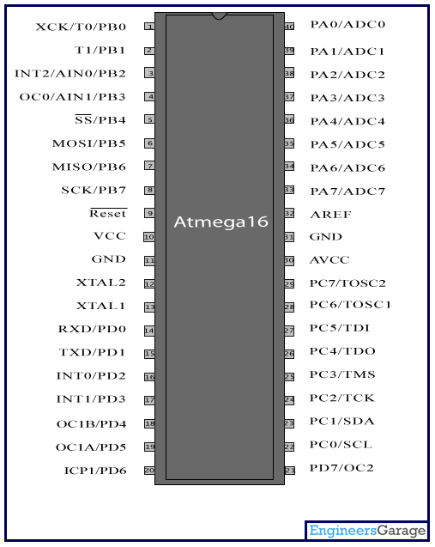

|  |
| --- |
|  |
|  |

Top of Form

Top of Form

Bottom of Form

* 1. **Solid state relay:-**

A solid-state relay (SSR) is an electronic switching device that switches on or off when a small external voltage is applied across its control terminals. SSRs consist of a sensor which responds to an appropriate input (control signal), a solid-state electronic switching device which switches power to the load circuitry, and a coupling mechanism to enable the control signal to activate this switch without mechanical parts. The [relay](https://en.wikipedia.org/wiki/Relay) may be designed to switch either AC or DC to the load. It serves the same function as an electromechanical [relay](https://en.wikipedia.org/wiki/Relay), but has no [moving parts](https://en.wikipedia.org/wiki/Moving_parts).

Packaged solid-state relays use power [semiconductor](https://en.wikipedia.org/wiki/Semiconductor) devices such as [thyristors](https://en.wikipedia.org/wiki/Thyristor) and [transistors](https://en.wikipedia.org/wiki/Transistor), to switch currents up to around a hundred amperes. Solid-state relays have fast switching speeds compared with electromechanical relays, and have no physical contacts to wear out. Application of solid-state relays must consider their lower ability to withstand momentary overload, compared with electromechanical contacts, and their higher "on" state resistance. Unlike an electromechanical relay, a solid-state relay provides only limited switching arrangements ([SPST switching](https://en.wikipedia.org/wiki/SPST_switch)).

**Operation:**

An SSR based on a single MOSFET, or multiple MOSFETs in a paralleled array, can work well for DC loads. MOSFETs have an inherent substrate diode that conducts in the reverse direction, so a single MOSFET cannot block current in both directions. For AC (bi-directional) operation two MOSFETs are arranged back-to-back with their source pins tied together. Their drain pins are connected to either side of the output. The substrate diodes are alternately reverse biased to block current when the relay is off. When the relay is on, the common source is always riding on the instantaneous signal level and both gates are biased positive relative to the source by the photo-diode.

It is common to provide access to the common source so that multiple MOSFETs can be wired in parallel if switching a DC load. Usually a network is provided to speed the turn-off of the MOSFET when the control input is removed.

In AC circuits, [SCR](https://en.wikipedia.org/wiki/Silicon-controlled_rectifier) or [TRIAC](https://en.wikipedia.org/wiki/TRIAC) relays inherently switch off at the points of zero load current. The circuit will never be interrupted in the middle of a sine wave peak, preventing the large transient voltages that would otherwise occur due to the sudden collapse of the [magnetic field](https://en.wikipedia.org/wiki/Magnetic_field) around the inductance. This feature is called zero-crossover switching.

## **Advantages over mechanical relays:**

Most of the relative advantages of solid state and electromechanical relays are common to all solid-state as against electromechanical devices.

* Slimmer profile, allowing tighter packing.
* Totally silent operation
* SSRs switch faster than electromechanical relays; the switching time of a typical optically coupled SSR is dependent on the time needed to power the LED on and off - of the order of microseconds to milliseconds
* Increased lifetime, even if it is activated many times, as there are no moving parts to wear and no contacts to pit or build up carbon
* Output resistance remains constant regardless of amount of use
* Clean, [bounceless](https://en.wikipedia.org/wiki/Contact_bounce) operation
* No sparking, allows it to be used in explosive environments, where it is critical that no spark is generated during switching
* Inherently smaller than a mechanical relay of similar specification (if desired may have the same "casing" form factor for interchangeability).
* Much less sensitive to storage and operating environment factors such as [mechanical shock](https://en.wikipedia.org/wiki/Shock_%28mechanics%29), [vibration](https://en.wikipedia.org/wiki/Vibration), humidity, and external magnetic fields.

Solid State Relay Switch is a simple kit which will help you control (ON / OFF) a single high power circuit from a low power drive.

* Load – 24 to 240 VAC @ 500 W
* Trigger voltage – 2 to 5 VDC (TTL) @ 10 mA
* Input isolated with use of Optocoupler
* Power Battery Terminal (PBT) for easy input 230 VAC mains and load connection
* Terminal pins for connecting input trigger signal
* Heat sink for TRIAC

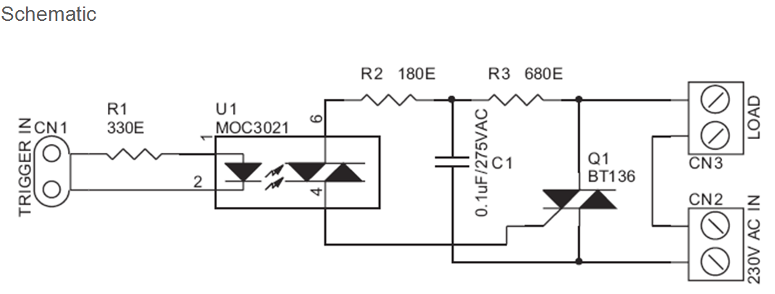

**Component Description:**

**MOC3021:**

It is a 6 pin Optocoupler IC which consists of an Infrared emitting diode optically coupled to a photo TRIAC. Some of the main applications of this IC are solenoids or control valves, solid state relays, motor control, incandescent lamp dimmer, AC power switch etc.

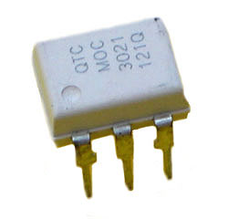

It can be used for 115V and 240V AC applications. Pins 1 and 2 of the IC ARE THE Anode and Cathode of the diode while Pins 6 and 4 are the main terminals.

|  |
| --- |
| Features: |
| http://www.futurlec.com/arrow1.gifExcellent IFT Stability-IR Emitting Diode has Low Degradation  http://www.futurlec.com/arrow1.gifHigh Isolation Voltage-Minimum 5300 VAC RMS  http://www.futurlec.com/arrow1.gifUL Recognized  http://www.futurlec.com/arrow1.gifPeak Blocking Voltage,250V-MOC301XM/400V-MOC302XM |
| **Pin Description** |
|  |
| |  |  | | --- | --- | | **Pin Number** | **Description** | | 1 | Anode | | 2 | Cathode | | 3 | No Connection | | 4 | Main Terminal | | 5 | Not Connected | | 6 | Main Terminal | |  |  |   **Pin Layout:** |

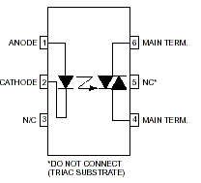

#### **BT136:**

It is the TRIAC IC used in the project. This TRIAC can be generally used in applications where high bidirectional transient and blocking voltage is involved.

The maximum off-state voltage or blocking voltage is 600V and up to 4A of on-state RMS current can be allowed. The common applications are motor control, industrial lighting, heating applications and static switching.

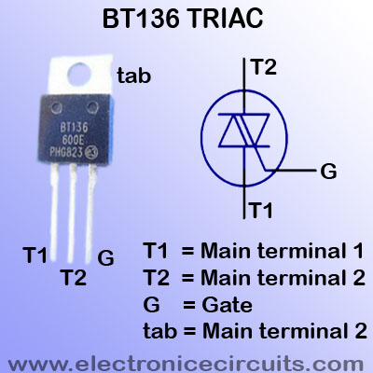

* 1. **Pre-failure alarm:-**

This is a simple current monitoring circuit. Which will continuous monitor the current through a particular branch of the network and any abrupt changes will result in alarm so that we will know about the malfunctioning or the abnormalities in the system and we shall be able to repair the fault before it causes any damage to the system.

It will be a monitoring on current level by the microcontroller, where we will give the levels of threshold current and the crossing of the thresholds will result in alarm which will alert us with the bad condition

8

of the system and we can take preventive measures so that further losses due to the failure of the heater band or the thermocouple can be reduces or minimized.

* 1. **LCD interfacing:-**

WHAT IS LCD?

LCD stands for Liquid Crystal Display, is an electronic device which is used for data display. LCDs are preferable over seven segments and LEDs as they can easily represent data in form of alphabets, characters, numbers or animations. LCDs are very easy to program and make your work quite attractive and simple. Numerous types of LCDs are available in market such as 16X2, 16X4, 20X2, 20X4, graphical LCDs (128X64) etc. The LCD which we are using is 16X2 alphanumeric LCD, it display 32 characters in two rows means in one row we have 16 characters

PIN DESCRIPTION OF LCD

16X2 LCD can interface with AVR microcontroller by using two modes, 4-bit mode or 8-bit mode. In this article we will use 8-bit mode for interfacing. In 8-bit mode we send command to LCD by using eight data lines (D0-D7) while in 4-bit mode we use four data lines (D5-D7) for sending command and data. These data lines can be connected to any port of Atmega32.

|  |  |  |
| --- | --- | --- |
| **PIN NO.** | **PIN NAME** | **DESCRIPTION** |
| 1 | VCC | Supply pin (+5V DC) |
| 2 | VDD | Ground pin |
| 3 | VEE | Contrast pin |
| 4 | RS | Register selection pin (either data or command)RS=0: Command Register ,  RS=1: Data Register |
| 5 | RW | Selects Read or Write operationRW=0: for write  RW=1:  for read |
| 6 | E | Enable pin |
| 7 | D0 | Data pin 0 |
| 8 | D1 | Data pin 1 |
| 9 | D2 | Data pin 2 |
| 10 | D3 | Data pin 3 |
| 11 | D4 | Data pin 4 |
| 12 | D5 | Data pin 5 |
| 13 | D6 | Data pin 6 |
| 14 | D7 | Data pin 7 |

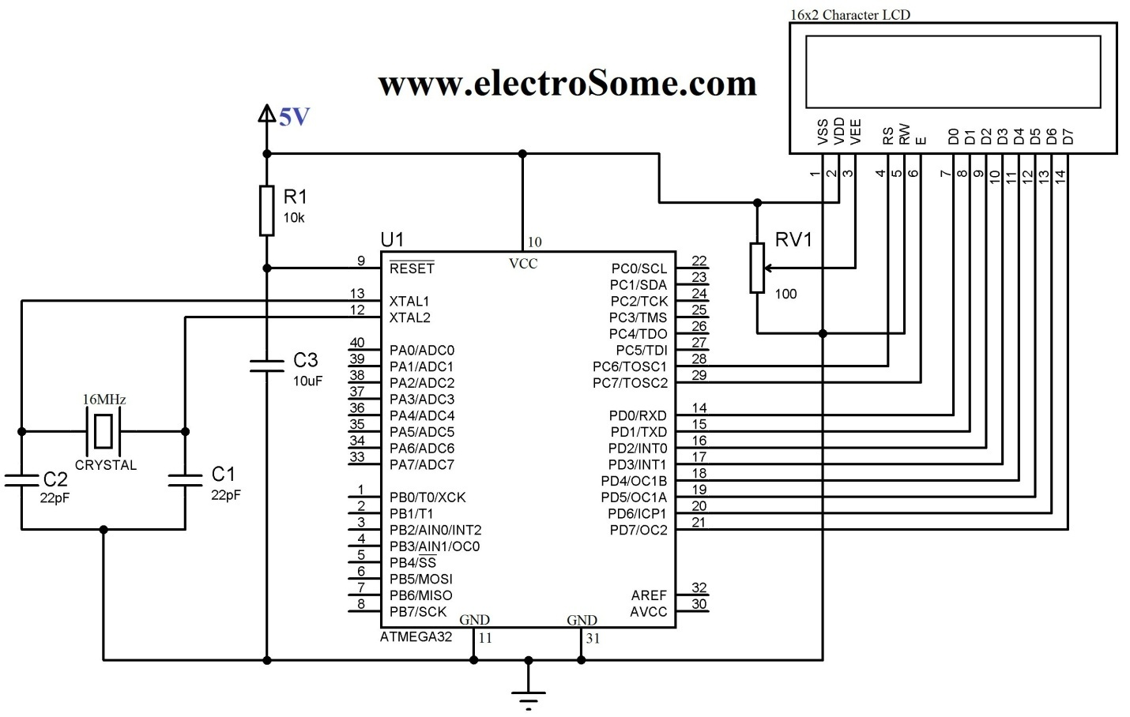

[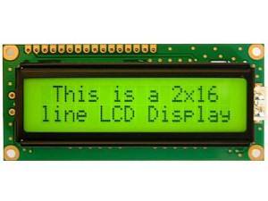](https://electrosome.com/wp-content/uploads/2013/05/16x2-Character-LCD.jpg)

16×2 Character LCD

Interfacing 16×2 LCD with Atmega32 Atmel AVR Microcontroller using Atmel Studio is bit complex as there is no built in libraries. To solve this difficulty we developed a LCD library which includes the commonly used features. Just include our header file and enjoy. You can download the header file from the bottom of this article.

16×2 LCD can be interfaced with a microcontroller in 8 Bit or 4 Bit mode. These differs in how data and commands are send to LCD. In 8 Bit mode character data (as 8 bit ASCII) and LCD command are sent through the data lines D0 to D7. That is 8 bit data is send at a time and data strobe is given through E of the LCD.

But 4 Bit mode uses only 4 data lines D4 to D7. In this 8 bit data is divided into two parts and are sent sequentially through the data lines. The idea of 4 bit communication is introduced to save pins of microcontroller. 4 bit communication is bit slower than 8 bit but this speed difference has no significance as LCDs are slow speed devices. Thus 4 bit mode data transfer is most commonly used

To display the readings and status of the system we are using a simple LCD display interfacing along with the other interfacings like computer and radio frequency module. This displays the contents provided by the microcontroller in the ASCII format. No additional circuit is required to interface this with the controller it can be directly connected to the controller along with other peripherals as shown in the above circuit diagram.

* 1. **RF 432:**

The RF432 spread-spectrum radio includes a USB port to make it easier to connect to newer computers that do not have RS-232 ports. This 50 mW spread-spectrum radio/modem operates in the 2.450 to 2.460 GHz frequency range, which is used worldwide. The RF432 can transmit data to another RF432 radio, an RF416 radio, or a CR216(X) datalogger.

The RF432 supports point-to-point and point-to-multipoint communications. Although it typically serves as a base station modem/radio, the RF432 can connect to the datalogger RS-232 port to serve as a field modem (requires a null modem cable and a field power cable).

## Benefits and Features

* USB port for connecting to a computer; RS-232 port for connecting to a datalogger
* Rugged, low-cost transceivers
* Can be used in the field as a transceiver or in the office as the base station
* Transmits up to one mile with omnidirectional antenna; up to 10 miles with higher gain directional antennas at ideal conditions
* Settings stored in non-volatile memory
* Designed for use in PakBus networks
* Frequency-hops over 25 channels avoids interference from other spread spectrum radios
* Optional extended temperature testing
* Faster communication due to elimination of some small "link state packets"
* Ability to have stand-alone RF router/repeaters (up to 8 repeaters)
* Greater immunity to interference and RF collisions by using RF retries
* Reduced power consumption by the datalogger, as the radios perform "packet address filtering"
* Built-in setup menus allow access to advanced functionality

**Chapter 5: Coding**

CODE FOR INTERFACING LCD:

We use Atmel studio 6 for development of code and the code is written in C language.

#ifndef F\_CPU

# define F\_CPU 16000000UL // clock speed is 16MHz

#endif

#include<avr/io.h>        // AVR header

#include<util/delay.h>    // delay header

//\*\*\*\*\*\*\*\*\*\*\*\*\*\*\*\*\*\*LCD PROGRAM STARTS\*\*\*\*\*\*\*\*\*\*\*\*\*\*\*\*\*\*\*\*\*//

#define LCD\_DATA PORTB          // port B is selected as LCD data port

#define ctrl PORTD               //  port D is selected as LCD command port

#define en PD7                  // enable signal is connected to port D pin 7

#define rw PD6                  // read/write signal is connected to port D pin 6

#define rs PD5                  // register select signal is connected to port D pin 5

void LCD\_cmd(unsigned char cmd);

void init\_LCD(void);

void LCD\_write(unsigned char data);

int main(void)

{

DDRB=0xFF;              // set LCD data port as output

DDRD=0xE0;              // set LCD signals (RS, RW, E) as out put

init\_LCD();             // initialize LCD

\_delay\_ms(100);         // delay of 100 Milli seconds

LCD\_cmd(0x0C);          // display on, cursor off

\_delay\_ms(100);

LCD\_write(‘ ‘);         // call a function to display space on LCD

\_delay\_ms(1);

LCD\_write(‘ ‘);         // call a function to display space on LCD

\_delay\_ms(1);

LCD\_write(‘ ‘);         // call a function to display space on LCD

\_delay\_ms(1);

LCD\_write(‘ ‘);         // call a function to display space on LCD

\_delay\_ms(1);

LCD\_write(‘ ‘);         // call a function to display space on LCD

\_delay\_ms(1);

LCD\_write(‘A’);         // call a function to display “A” on LCD

\_delay\_ms(100);

LCD\_write(‘V’);         // call a function to display “V” on LCD

\_delay\_ms(100);

LCD\_write(‘R’);         // call a function to display “R” on LCD

\_delay\_ms(100);

LCD\_cmd(0xC0);          // move cursor to the start of 2nd line

\_delay\_ms(100);

LCD\_cmd(0x0C);          // display on, cursor off

\_delay\_ms(100);

LCD\_write(‘ ‘);         // call a function to display space on LCD

\_delay\_ms(1);

LCD\_write(‘ ‘);

\_delay\_ms(1);

LCD\_write(‘ ‘);

\_delay\_ms(1);

LCD\_write(‘A’);        // call a function to display “A” on LCD

\_delay\_ms(100);

LCD\_write(‘t’);        // call a function to display “t” on LCD

\_delay\_ms(100);

LCD\_write(‘m’);        // call a function to display “m” on LCD

\_delay\_ms(100);

LCD\_write(‘e’);        // call a function to display “e” on LCD

\_delay\_ms(100);

LCD\_write(‘g’);        // call a function to display “g” on LCD

\_delay\_ms(100);

LCD\_write(‘a’);        // call a function to display “a” on LCD

\_delay\_ms(100);

LCD\_write(‘3’);        // call a function to display “3” on LCD

\_delay\_ms(100);

LCD\_write(‘2’);        // call a function to display “2” on LCD

\_delay\_ms(100);

LCD\_cmd(0x0E);          // make display ON, cursor ON

\_delay\_ms(1);

return 0;

}

void init\_LCD(void)

{

LCD\_cmd(0x38);           // initialization in 8bit mode of 16X2 LCD

\_delay\_ms(1);

LCD\_cmd(0x01);          // make clear LCD

\_delay\_ms(1);

LCD\_cmd(0x02);          // return home

\_delay\_ms(1);

LCD\_cmd(0x06);          // make increment in cursor

\_delay\_ms(1);

LCD\_cmd(0x80);          // “8” go to first line and “0” is for 0th position

\_delay\_ms(1);

return;

}

//\*\*\*\*\*\*\*\*\*\*\*\*\*\*sending command on LCD\*\*\*\*\*\*\*\*\*\*\*\*\*\*\*//

void LCD\_cmd(unsigned char cmd)

{

LCD\_DATA = cmd;      // data lines are set to send command

PORTD  &= ~(1<<rs);  // RS sets 0

PORTD  &= ~(1<<rw);  // RW sets 0

PORTD  |= (1<<en);   // make enable from high to low

\_delay\_ms(100);

PORTD  &= ~(1<<en);

return;

}

//\*\*\*\*\*\*\*\*\*\*\*\*\*\*\*\*\*write data on LCD\*\*\*\*\*\*\*\*\*\*\*\*\*\*\*\*\*//

void LCD\_write(unsigned char data)

{

LCD\_DATA= data;       // data lines are set to send command

PORTD  |= (1<<rs);    // RS sets 1

PORTD  &= ~(1<<rw);   // RW sets 0

PORTD  |= (1<<en);    // make enable from high to low

\_delay\_ms(100);

PORTD &= ~(1<<en);

return ;

}

**Chapter 6: Advantages and disadvantages**

**Advantages**:-

* Fully automatic, so that it controls the temperature without using it manually.
* Pre and post alarm reduces losses in production process
* High temperature operation as range of thermocouple is very large and vast variety of types are present in market to pick the one most suitable to the application.
* Fastest response to temperature changes. Its due to use of digital switching relays which reduce noise and lag in the operation.

**Disadvantages:-**

* Low sensitivity to small temperature changes and less repeatability as the range is very large.
* Extension wire must be of the same thermocouple type other wise noise occurs in the readings.
* Wire may pick up radiated electrical noise if not shielded
* Low accuracy

**Chapter 7: Applications and Future scope**

**Applications:-**

* Plastic injection molding machinery
* Food processing equipment
* Deicing
* Semiconductor processing
* Heat treating
* Medical equipment
* Industrial heat treating
* Packaging equipment

**Future scope:-**

* Multiple heaters and sensors in same system to obtain desired output. It will provide user with higher control over the plant temperature.
* Processor of high capacity can be used if the requirement of application is demanding
* Power supply circuit can be improved. As here we are using components with various supply voltages the power supply circuit is quite complicated. But all the equipments are of same supply then the circuit can be reduced by a significant amount.

**Chapter 8: Conclusion**

we can conclude that the proposed temperature controller design is good for commercial use. And can be considered for actual use in the process plant. The proposed circuit design is having good stability high range and admirable features like remote accessibility and pre failure alarm which makes it competitive with the other designs in the market and hence our objective of the project is fulfilled using this design.

**References**

* Texas Instruments, Post Office Box 655303, Dallas, Texas 75265 Copyright © 2014, Texas Instruments Incorporated
* Motorola, Inc., Phoenix, AZ, Temperature Measurement and Display Using the MC68HC05B4 and the MC14489,1990. Motorola Semiconductor Application Note AN431.
* Ali IA, Abdalla AM, 1993. A microcomputer-based system for all-year-round temperature control in greenhouses in dry arid lands. Compute Electron Agr 8(3): 195-210.
* Temperature control using ATmega16-IIT KHARAGPUR Virtual Lab, <http://iitkgp.vlab.co.in>
* Avinash, Interfacing LM35 Temperature Sensor with PIC Microcontroller, http://extremeelectronics.co.in
* [www.datasheets4u.com](http://www.datasheets4u.com)
* [www.8051.com](http://www.8051.com)
* <http://www.lammertbies.nl/comm/>
* <https://electrosome.com/interfacing-lcd-with-8051-using-keil-c-at89c51/>
* <https://www.pantechsolutions.net/8051-ps2-lab-kit-article/how-to-interface-zigbee-with-8051.html#sthash.roynhUfK.dpuf>
* [www.pantechsolutions.net/8051-ps2-lab-kit-article/how-to-interface-zigbee-with-8051.htm](http://www.pantechsolutions.net/8051-ps2-lab-kit-article/how-to-interface-zigbee-with-8051.htm)

**Datasheets**

**1.LCD:**

### **Pin Description:**

### 

|  |  |  |
| --- | --- | --- |
| **Pin No** | **Function** | **Name** |
| 1 | Ground (0V) | Ground |
| 2 | Supply voltage; 5V (4.7V – 5.3V) | Vcc |
| 3 | Contrast adjustment; through a variable resistor | VEE |
| 4 | Selects command register when low; and data register when high | Register Select |
| 5 | Low to write to the register; High to read from the register | Read/write |
| 6 | Sends data to data pins when a high to low pulse is given | Enable |
| 7 | 8-bit data pins | DB0 |
| 8 | DB1 |
| 9 | DB2 |
| 10 | DB3 |
| 11 | DB4 |
| 12 | DB5 |
| 13 | DB6 |
| 14 | DB7 |
| 15 | Backlight VCC (5V) | Led+ |
| 16 | Backlight Ground (0V) | Led- |
|  |  |  |

### **Pin digram:**16 x 2 LCD PinOut | 16x2 Character LCD Module Pin diagram

* LCD (Liquid Crystal Display) screen is an electronic display module and find a wide range of applications.
* A 16x2 LCD display is very basic module and is very commonly used in various devices and circuits.
* These modules are preferred over [seven segments](http://www.engineersgarage.com/content/seven-segment-display) and other multi segment [LED](http://www.engineersgarage.com/content/led)s.
* The reasons being: LCDs are economical; easily programmable; have no limitation of displaying special & even [custom characters](http://www.engineersgarage.com/microcontroller/8051projects/create-custom-characters-LCD-AT89C51) (unlike in seven segments), [animations](http://www.engineersgarage.com/microcontroller/8051projects/display-custom-animations-LCD-AT89C51) and so on.
* A **16x2 LCD** means it can display 16 characters per line and there are 2 such lines. In this LCD each character is displayed in 5x7 pixel matrix. This LCD has two registers, namely, Command and Data.
* The command register stores the command instructions given to the LCD. A command is an instruction given to LCD to do a predefined task like initializing it, clearing its screen, setting the cursor position, controlling display etc.
* The data register stores the data to be displayed on the LCD. The data is the ASCII value of the character to be displayed on the LCD. Click to learn more about internal structure of a [LCD](http://www.engineersgarage.com/insight/how-lcd-works).

**2.Atmega 16:**

Features

• High-performance, Low-power AVR® 8-bit Microcontroller

• Advanced RISC Architecture – 131 Powerful Instructions – Most Single-clock Cycle Execution – 32 x 8 General Purpose Working Registers – Fully Static Operation – Up to 16 MIPS Throughput at 16 MHz – On-chip 2-cycle Multiplier

• Nonvolatile Program and Data Memories – 16K Bytes of In-System Self-Programmable Flash Endurance: 10,000 Write/Erase Cycles – Optional Boot Code Section with Independent Lock Bits In-System Programming by On-chip Boot Program True Read-While-Write Operation – 512 Bytes EEPROM Endurance: 100,000 Write/Erase Cycles – 1K Byte Internal SRAM – Programming Lock for Software Security

• JTAG (IEEE std. 1149.1 Compliant) Interface – Boundary-scan Capabilities According to the JTAG Standard – Extensive On-chip Debug Support – Programming of Flash, EEPROM, Fuses, and Lock Bits through the JTAG Interface

• Peripheral Features – Two 8-bit Timer/Counters with Separate Prescalers and Compare Modes – One 16-bit Timer/Counter with Separate Prescaler, Compare Mode, and Capture Mode – Real Time Counter with Separate Oscillator – Four PWM Channels – 8-channel, 10-bit ADC 8 Single-ended Channels 7 Differential Channels in TQFP Package Only 2 Differential Channels with Programmable Gain at 1x, 10x, or 200x – Byte-oriented Two-wire Serial Interface – Programmable Serial USART – Master/Slave SPI Serial Interface – Programmable Watchdog Timer with Separate On-chip Oscillator – On-chip Analog Comparator

• Special Microcontroller Features – Power-on Reset and Programmable Brown-out Detection – Internal Calibrated RC Oscillator – External and Internal Interrupt Sources – Six Sleep Modes: Idle, ADC Noise Reduction, Power-save, Power-down, Standby and Extended Standby

• I/O and Packages – 32 Programmable I/O Lines – 40-pin PDIP, 44-lead TQFP, and 44-pad MLF

• Operating Voltages – 2.7 - 5.5V for ATmega16L – 4.5 - 5.5V for ATmega16

• Speed Grades – 0 - 8 MHz for ATmega16L – 0 - 16 MHz for ATmega16

• Power Consumption @ 1 MHz, 3V, and 25°C for ATmega16L – Active: 1.1 mA – Idle Mode: 0.35 mA – Power-down Mode: < 1 µA

**Pin diagram:**

****

### **Pin Description:**

|  |  |  |  |
| --- | --- | --- | --- |
| **Pin No.** | **Pin name** | **Description** | **Alternate Function** |
| 1 | (XCK/T0) PB0 | I/O PORTB, Pin 0 | T0: Timer0 External Counter Input.  XCK : USART External Clock I/O |
| 2 | (T1) PB1 | I/O PORTB, Pin 1 | T1:Timer1 External Counter Input |
| 3 | (INT2/AIN0) PB2 | I/O PORTB, Pin 2 | AIN0: Analog Comparator Positive I/P  INT2: External Interrupt 2 Input |
| 4 | (OC0/AIN1) PB3 | I/O PORTB, Pin 3 | AIN1: Analog Comparator Negative I/P  OC0 : Timer0 Output Compare Match Output |
| 5 | (SS) PB4 | I/O PORTB, Pin 4 | In System Programmer (ISP)  Serial Peripheral Interface (SPI) |
| 6 | (MOSI) PB5 | I/O PORTB, Pin 5 |
| 7 | (MISO) PB6 | I/O PORTB, Pin 6 |
| 8 | (SCK) PB7 | I/O PORTB, Pin 7 |
| 9 | RESET | Reset Pin, Active Low Reset |  |
| 10 | Vcc | Vcc = +5V |  |
| 11 | GND | GROUND | |
| 12 | XTAL2 | Output to Inverting Oscillator Amplifier | |
| 13 | XTAL1 | Input to Inverting Oscillator Amplifier | |
| 14 | (RXD) PD0 | I/O PORTD, Pin 0 | USART Serial Communication Interface |
| 15 | (TXD) PD1 | I/O PORTD, Pin 1 |
| 16 | (INT0) PD2 | I/O PORTD, Pin 2 | External Interrupt INT0 |
| 17 | (INT1) PD3 | I/O PORTD, Pin 3 | External Interrupt INT1 |
| 18 | (OC1B) PD4 | I/O PORTD, Pin 4 | PWM Channel Outputs |
| 19 | (OC1A) PD5 | I/O PORTD, Pin 5 |
| 20 | (ICP) PD6 | I/O PORTD, Pin 6 | Timer/Counter1 Input Capture Pin |
| 21 | PD7 (OC2) | I/O PORTD, Pin 7 | Timer/Counter2 Output Compare Match Output |
| 22 | PC0 (SCL) | I/O PORTC, Pin 0 | TWI Interface |
| 23 | PC1 (SDA) | I/O PORTC, Pin 1 |
| 24 | PC2 (TCK) | I/O PORTC, Pin 2 | JTAG Interface |
| 25 | PC3 (TMS) | I/O PORTC, Pin 3 |
| 26 | PC4 (TDO) | I/O PORTC, Pin 4 |
| 27 | PC5 (TDI) | I/O PORTC, Pin 5 |
| 28 | PC6 (TOSC1) | I/O PORTC, Pin 6 | Timer Oscillator Pin 1 |
| 29 | PC7 (TOSC2) | I/O PORTC, Pin 7 | Timer Oscillator Pin 2 |
| 30 | AVcc | Voltage Supply = Vcc for ADC | |
| 31 | GND | GROUND | |
| 32 | AREF | Analog Reference Pin for ADC | |
| 33 | PA7 (ADC7) | I/O PORTA, Pin 7 | ADC Channel 7 |
| 34 | PA6 (ADC6) | I/O PORTA, Pin 6 | ADC Channel 6 |
| 35 | PA5 (ADC5) | I/O PORTA, Pin 5 | ADC Channel 5 |
| 36 | PA4 (ADC4) | I/O PORTA, Pin 4 | ADC Channel 4 |
| 37 | PA3 (ADC3) | I/O PORTA, Pin 3 | ADC Channel 3 |
| 38 | PA2 (ADC2) | I/O PORTA, Pin 2 | ADC Channel 2 |
| 39 | PA1 (ADC1) | I/O PORTA, Pin 1 | ADC Channel 1 |
| 40 | PA0 (ADC0) | I/O PORTA, Pin 0 | ADC Channel 0 |

**3.Thermocouple:**

MAXIMUM TEMPERATURE RANGE:1. Thermocouple Grade

– 328 to 2282°F

– 200 to 1250°C

2.Thermocouple Grade

– 328 to 2282°F

– 200 to 1250°C

3. Extension Grade:

32 to 392°F

0 to 200°C

Standard: 2.2°C or 0.75% Above 0°C

2.2°C or 2.0% Below 0°C

Special: 1.1°C or 0.4%

COMMENTS, BARE WIRE ENVIRONMENT:Clean Oxidizing and Inert; Limited Use in

Vacuum or Reducing; Wide Temperature

Range; Most Popular Calibration

TEMPERATURE IN DEGREES °C

REFERENCE JUNCTION AT 0°C

**4. RF 432:**

FEATURES:

* Low Rds(on) at high voltage.
* Improved Inductive ruggedness
* Excellent high voltage stability
* Fast switching times
* Rugged polysilicon gate cell structure
* Low input capacitance
* Extended safe operating area
* Improved high temperature reliability
* TO-3 package (High voltage)

**MAXIMUM RATING:**

**Characteristic symbol RF 432 Unit**

1.Drain-source voltage Vdss 500 Vds

2. Drain-Gate voltage Vdgr 500 Vds

3.Gate-Source Voltage Vgs +-20 Vds

4.Continuous Drain Id 4.0 Ads

current

5.Drain Current Idm 16 Ads

pulsed

**5. Triacs BT136 series:**

Passivated triacs in a plastic envelope, SYMBOL PARAMETER MAX. UNIT intended for use in applications requiring high bidirectional transient and blocking BT136 voltage capability and high thermal cycling BT136 performance. Typical applications include motor control, industrial and domestic VDRM Repetitive peak off-state 600 V lighting, heating and static switching. voltages IT(RMS) RMS on-state current 4 A ITSM Non-repetitive peak on-state 25 A current

|  |  |
| --- | --- |
| PIN | DESCRIPTION |
| PIN 1 | Main terminal 1 (T1) |
| PIN 2 | Main terminal 2 (T2) |
| PIN 3 | gate (G)  Main terminal 2 (T2) |

|  |  |  |  |
| --- | --- | --- | --- |
| SYMBOL | PARAMETER | Value | Unit |
| V DRM | Repetitive peak off-state voltages | 600 | V |
| I T(RMS) | RMS on-state current | 4 | A |
| I TSM | Non-repetitive peak on-state current | 25 | A |

|  |  |  |  |  |  |  |
| --- | --- | --- | --- | --- | --- | --- |
| SYMBOL | PARAMETER | CONDITIONS | MIN | TYP | MAX | UNIT |
| R th j-mb | Thermal resistance  junction to mounting base | Full cycle  Half cycle | -  - | -  - | 3.0  3.7 | K/W  K/W |
| R th j-a | Thermal resistance  Junction to am bient | In free air | - | 60 | - | K/W |

**Applications:**

Motor control

Industrial and domestic lighting

Heating

Static switching

Blocking voltage to 600 V

On-state RMS current to 4 A

**6.Moc3021**:

250 V Phototriac Driver Output

• Gallium-Arsenide-Diode Infrared Source and Optically-Coupled Silicon Traic Driver (Bilateral Switch)

• UL Recognized . . . File Number E65085

• High Isolation . . . 7500 V Peak • Output Driver Designed for 220 V ac

• Standard 6-Terminal Plastic DIP

• Directly Interchangeable with Motorola MOC3020, MOC3021, MOC3022, and MOC3023

• Direct Replacements for: – TRW Optron OPI3020, OPI3021, OPI3022, and OPI3023; – General Instrument MCP3020, MCP3021, and MCP3022; – General Electric GE3020, GE3021, GE3022, and GE3023

electrical characteristics at 25°C free-air temperature (unless otherwise noted)

|  |  |  |  |
| --- | --- | --- | --- |
| PARAMETERS | TEST CONDITION | Min type Max | Unit |
| IR Static reverse current | VR = 3 V | 0.05 100 | mA |
| VF Static forward voltage | IF = 10 mA | 1.2 1.5 | V |
| I(DRM) Repetitive off-state current, either direction | V(DRM) = 400 V, | 10 100 | nA |
| dv/dt Critical rate of rise of off-state voltage | See Figure 1 | 100 | V/ms |
| dv/dt(c) Critical rate of rise of commutating voltage | IO = 15 mA, | 0.15 | V/ms |
| VTM Peak on-state voltage, either direction | ITM = 100 mA | 1.4 3 | V |
| IH Holding current, either direction |  | 100 | mA |